“Wait”, backtracking in CoTs of reasoning models are intentional

Executive Summary

Research problem: I employed mechanistic interpretability to better understand backtracking events that occur in the reasoning model’s chain-of-thought (CoT) during solving multi-step math problems. Backtracking events are instances when the model explicitly revises or corrects its reasoning mid-stream. This research effort was interested in three key questions:

RQ1: Does backtracking happen randomly or is it intentional and context-dependent?
RQ2: Can we identify neurons and features that signal backtracking?
RQ3: Can we derive a meaningful explanation for how backtracking occurs?

Why it’s worth pursuing: Backtracking events can serve as proxy signals for self-correction. This research ties into safety, because a model’s ability to self-correct is crucial for preventing errors that could lead to harmful outcomes. Understanding this mechanism better can help us design interventions to reinforce safe reasoning. In the future, this might enable internal safeguards that steer the model away from unsafe, misaligned, or incorrect reasoning trajectories. It’d also make their internal decision-making more transparent and controllable.

High-level takeaways: Backtracking events consistently emerged when the model encountered error-prone steps or contradictions through repeated generations, indicating intentionality. Identifying neurons that signal backtracking is difficult and infeasible due to polysemanticity, but sparse autoencoders (SAEs) were successful in isolating interpretable backtracking features. Furthermore, attention pattern analysis revealed a broader reasoning mechanism that associates backtracking signals with special tokens (e.g. “/n”, “/n/n”, “<think>”).

Reflections: These are significant takeaways, because it indicates that the computation carrying out backtracking is not crammed into the next-token prediction, but rather is “cooked up” gradually as the model generates tokens (e.g. solving a multi-step math problem). It could also mean that the model has an internal representation of right versus wrong, allowing it to initiate backtracking when it detects a wrong trajectory.

Future direction and challenges: RQ3 was difficult to engage with due to time and resource constraints. While the experiments provided for RQ1 and RQ2 demonstrate promising initial results, more rigorous studies need to be conducted before we can reach definitive answers. Future work will address neuron-level interpretability limitations (Experiment 2) and SAE feature validity (Experiment 4) through feature ablation, linear probing, and steering vectors to robustly validate features and potentially steer model reasoning.

I’ll first formulate the problem and then cover key experiments and graphs that yielded the takeaways. Our problem setup includes a dataset of 1K CoTs generated by DeepSeek-R1-Distill-Qwen-1.5B on the multi-step math problems dataset MATH, annotated with backtracking phrases as shown on Figure 1. We have access to the ground-truth solutions and can check CoT’s correctness.
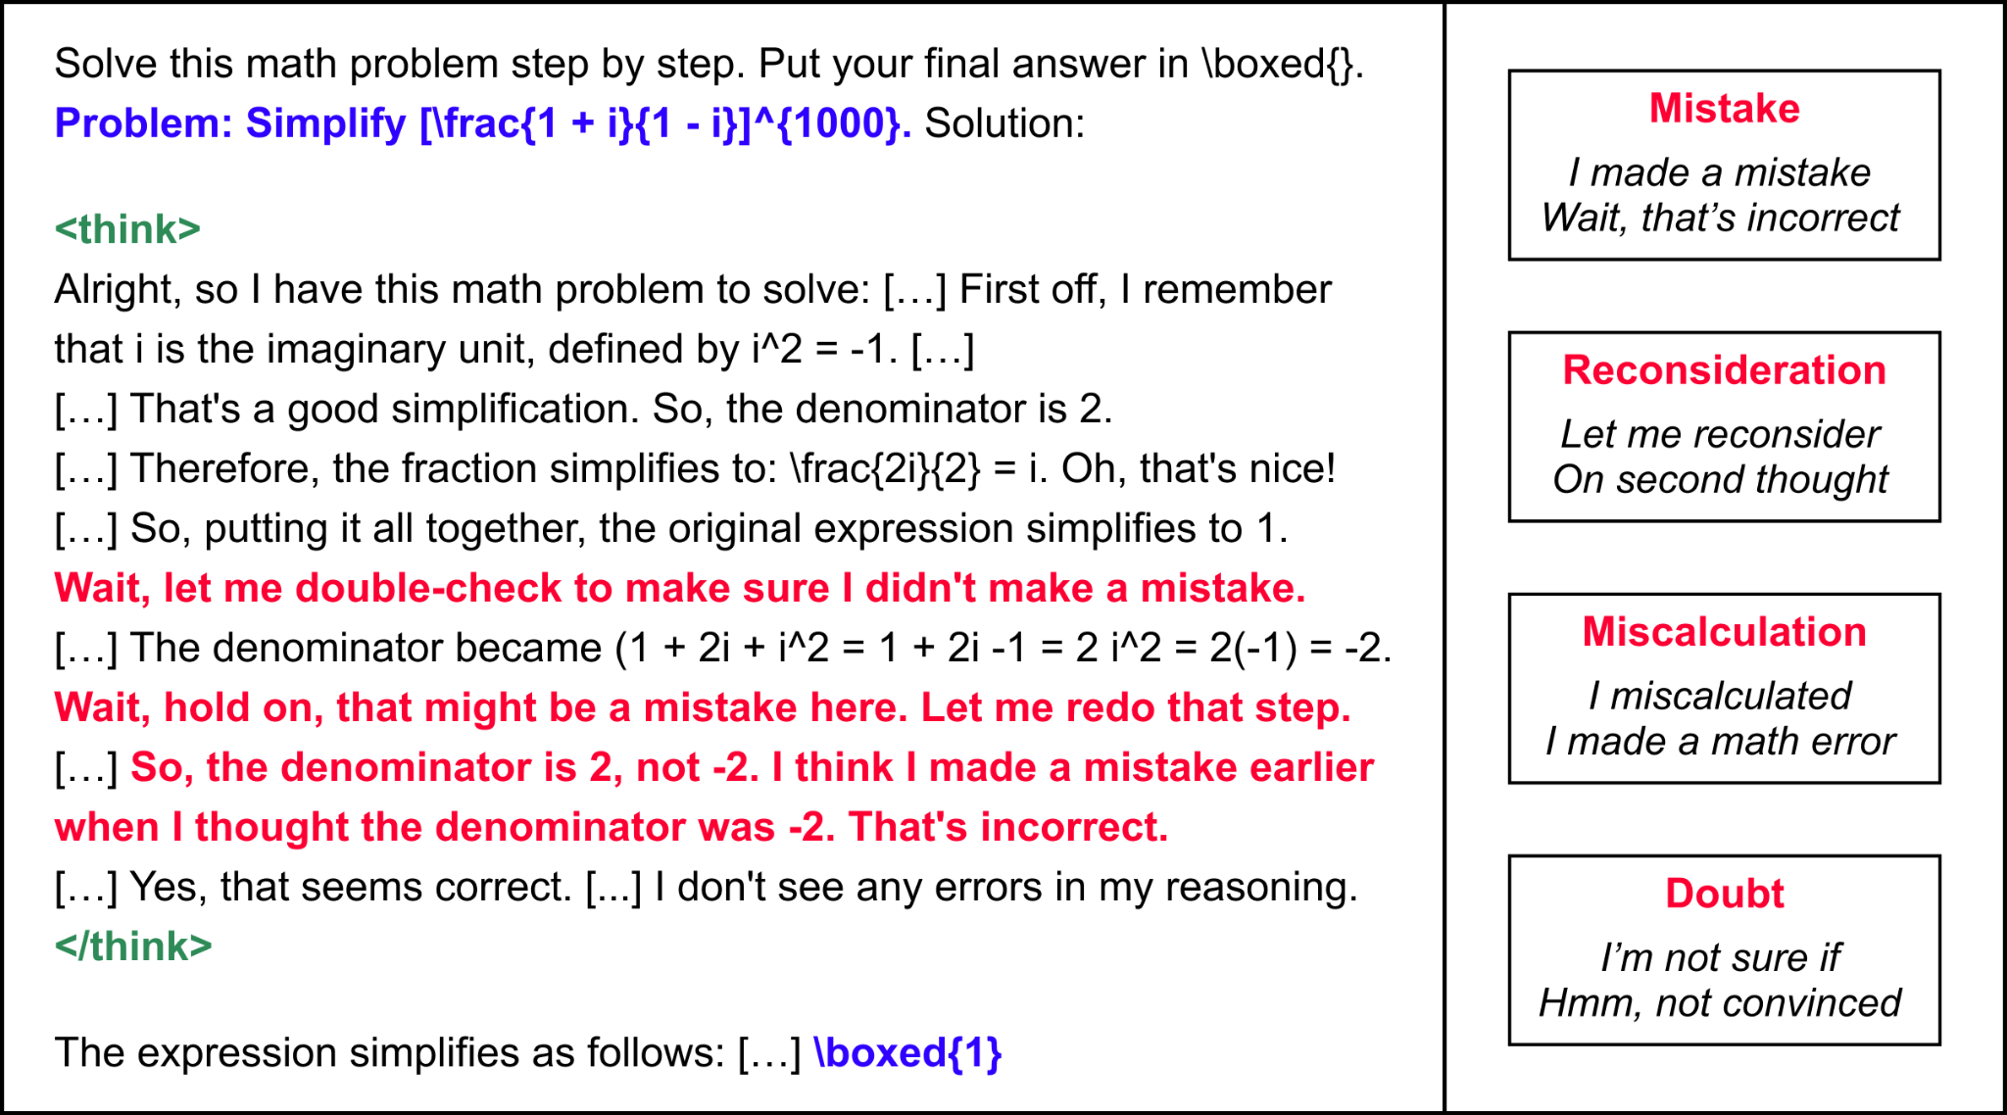
Figure 1: Left-hand side is an example problem with backtracking. Right-hand side shows examples of backtracking phrases used for filtering. Four categories identified were: mistake, reconsideration, miscalculation, and doubt.

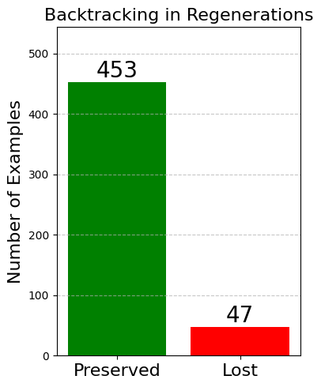
[Experiment 1] Backtracking consistency:
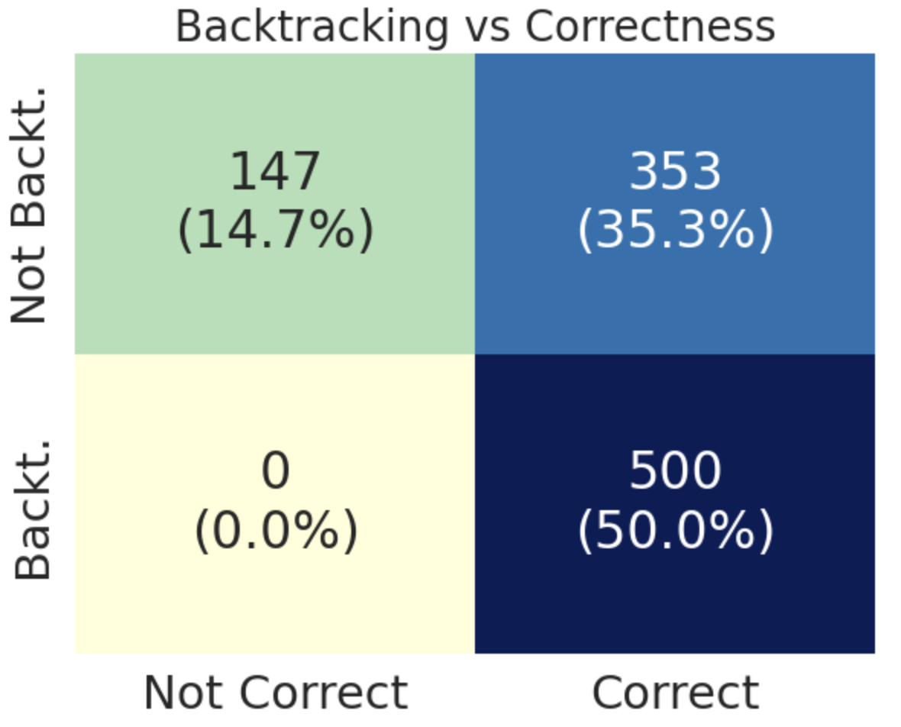
In the full 1K dataset, whenever the model
backtracked it answered the question correctly (100% acc), whereas when it did not backtrack it sometimes arrived at the incorrect result (70.6% acc). Intervening on the CoTs of 500 backtracking samples before the occurrence of the first backtracking phrase, I asked the model to generate from where it left off based on the context
beforehand. The model preserved Figure 2: Backtracking accuracy and consistency
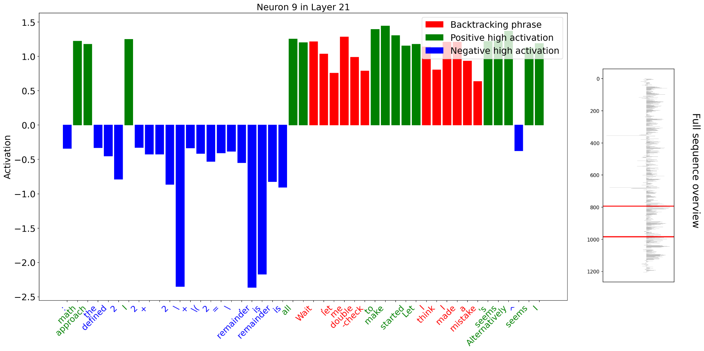
backtracking 90.6% (453 out of 500) of cases after intervention, indicating that backtracking is likely a deliberate response triggered by recognizing contradictions or errors rather than random occurrences (RQ1). This is shown on Figure 2. A context window size of 100 tokens w.r.t. original position was used to determine if backtracking was preserved. The first experiment may suffer from low intervention sample size or varying question difficulty in the dataset. However, initial results strongly suggest that backtracking is not coincidental, but rather intentional (RQ1).
Figure 3: Largest absolute value activations for neuron 9 in layer 21. Red: backtracking positions
[Experiment 2] Identifying backtracking neurons: The second experiment investigated the feasibility of direct neuron-level identification for backtracking (RQ2). I sampled activations for all ~1.5B neurons at both backtracking and non-backtracking sequence positions, collecting 150K backtracking and 350K non-backtracking activations. I computed each neuron’s ability to discriminate backtracking via the ROC-AUC. Figure 3 shows an example high AUC neuron. Despite strong initial effect sizes (Cohen’s d), neuron activations failed to generalize on separate validation sequences, firing frequently at non-backtracking positions. This highlights neuron polysemanticity. The full-sequence overview on the figure illustrates this clearly.

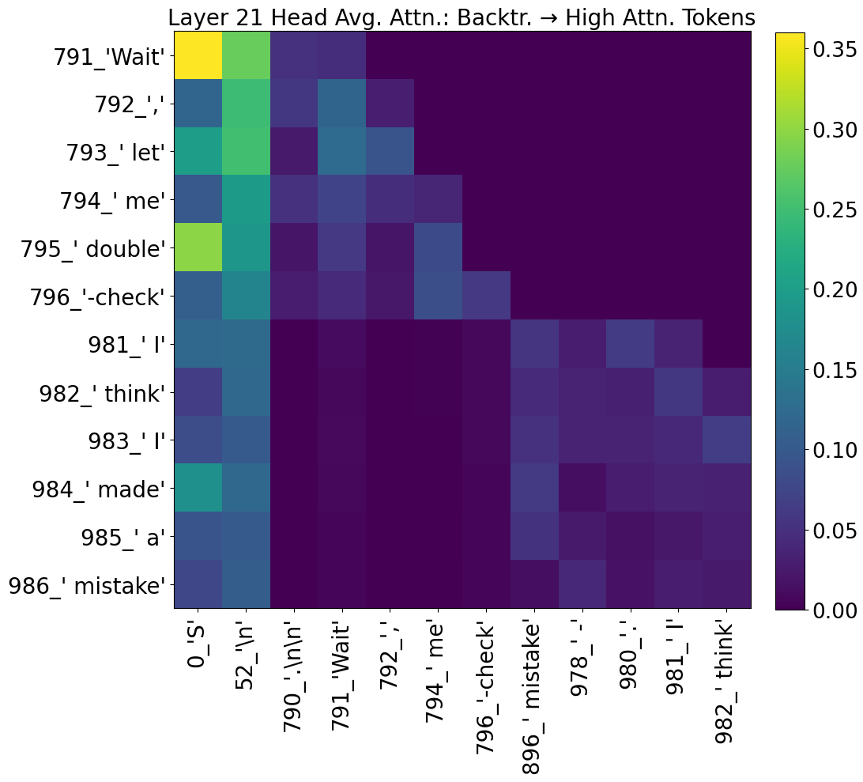
[Experiment 3] Attention pattern analysis: Third experiment analyzed attention patterns across dozens of examples. Visually examining 12 heads x 28 layers = 336 matrices, I noticed two prominent patterns: (1) Attending to previous token and (2) attending to a combination of the start token (always “S” in our data as the tokenizer encodes “Solve” as [“S”, “olve”]) and new-line token (“\n”) right after the think token (“<think>”). The first pattern is common in language models, but the second pattern was unexpected. The model was not attending to the “<think>” token itself, but the “\n” token following it. The strongest exhibition of this behavior was in the attention on layers 21, 25, 26, and 27. This pattern suggests backtracking computations may rely on special tokens serving as signals or triggers for reasoning state changes (RQ2, RQ3).

Figure 4: Attention map displays tokens the backtracking tokens attend to on layer 21 (average over heads). The x-axis shows tokens with high attention scores (>= 5 standard deviations above mean).

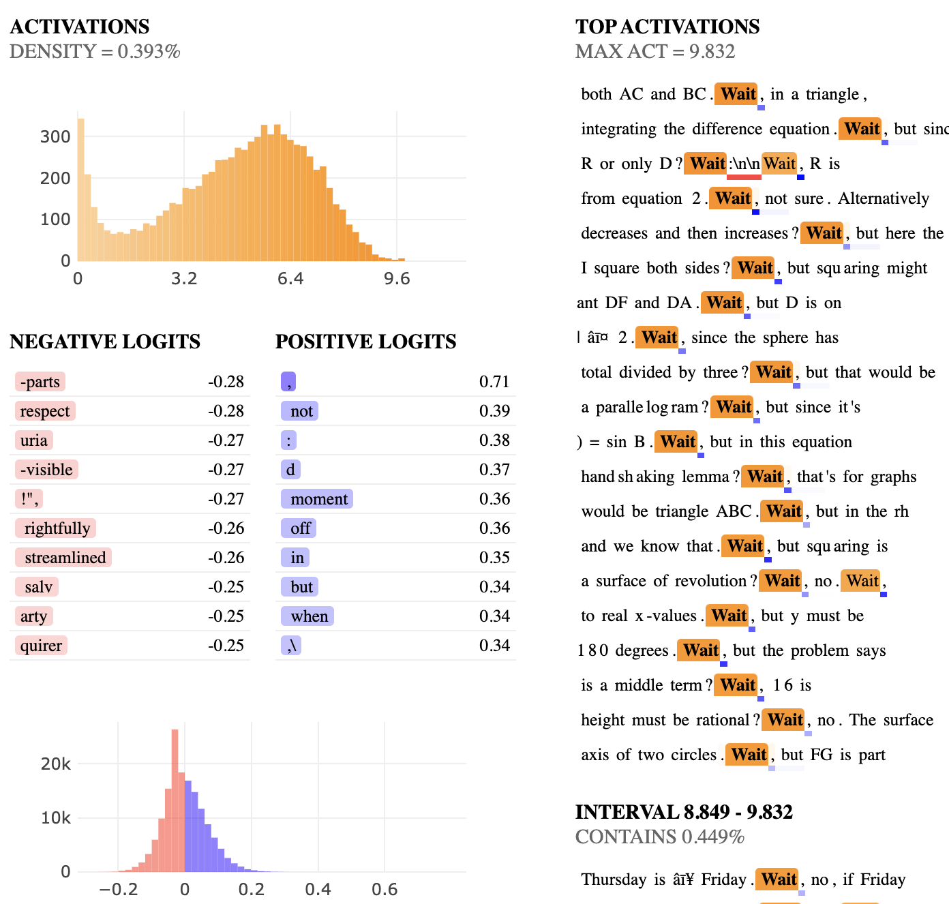
[Experiment 4] SAE for identifying backtracking features: Given layer 21’s role in attention-based backtracking signals observed in Experiment 3, I trained an SAE on the MLP output of this layer. I identified three features (19, 2242, 6685) that activated distinctly for the “Wait” token which is a very strong indicator for backtracking and self-correction (RQ2). Usually “Wait” initiates the backtracking in the CoTs. The next steps for this project will expand on this SAE with linear probes, feature ablation, and steering vectors.

Figure 5: SAE visualization for feature 19.

Introduction

Reasoning capabilities in language models have visibly improved thanks to chain-of-thought reasoning where models employ step-by-step problem solving before producing an answer. Within the reasoning trajectories a model generates, an intriguing phenomenon emerges: backtracking. We define backtracking as instances where the model explicitly revises or corrects its reasoning mid-stream. This typically manifests itself with generated sequences like “Wait, I made a mistake”, “Hmm, let me double-check”, or “Hold on, this is incorrect”. These phrases appear surprisingly human-like and resemble intentional reflection, but the mechanistic underpinnings of backtracking remain relatively unexplored.

Backtracking matters because it serves a proxy for internalized self-correction. This could be an essential ingredient for model reliability and safety. A model’s ability to detect or correct its own reasoning could reduce unintended and potentially harmful outputs. Understanding backtracking mechanisms in detail is therefore valuable and could give us a window into the model’s internal decision making process. This research effort set out to explore these dynamics more deeply.

I structured the research effort around three core research questions:
RQ1: Does backtracking happen randomly or is it intentional and context-dependent?
RQ2: Can we identify neurons and features that signal backtracking?
RQ3: Can we derive a meaningful explanation for how backtracking occurs?

To address these questions, I employed a mechanistic interpretability approach on a dataset of 1K multi-step math problem solutions (CoTs) generated by DeepSeek-R1-Distill-Qwen-1.5B. I annotated the CoTs with explicit backtracking phrases to enable the present analysis.

The methodological approach combined neuron-level activation analysis [Experiment 2], attention pattern examinations [Experiment 3], and sparse autoencoder (SAE) based feature extraction [Experiment 4] to decode how the model decides to backtrack. By probing activations of individual neurons, I initially sought clear signals uniquely associated with backtracking. However, neuron-level backtracking identification approaches were unsuccessful due to the polysemanticity (i.e. neurons firing in multiple distinct contexts make them harder to interpret). I overcame this interpretability barrier by leveraging SAEs. Attention pattern analyses further revealed that certain special tokens (e.g. new-line characters) and thinking tokens (“<think>”) were systematically involved in signaling backtracking events. My findings suggest backtracking is indeed intentional and context-driven rather than a random linguistic quirk. This intentionality was evidenced by experiments demonstrating that the model consistently preserved backtracking decisions even when I intervened and manipulated its context [Experiment 1].

This work is exploratory and may suffer from low data size and other biases including difficulty of questions in the used dataset, the way backtracking phrases were identified, and lack of replication and validation results. Despite these, my initial results highlight intriguing patterns worthy of deeper investigation. I will continue this research agenda and hope to contribute both insights and practical tools for future research.

Model

For this research effort, I used the deDeepSeek-R1-Distill-Qwen-1.5B model which is a distilled version of the original DeepSeek R1 reasoning model. The original DeepSeek R1 was notable for demonstrating explicit backtracking behavior during CoT reasoning on multi-step problems as highlighted in the original paper. Thankfully even this smaller distilled version is available via HuggingFace and exhibits similar backtracking behavior, making it ideal for this exploratory project. The choice of 1.5B model as opposed to the 7B or 14B models is due to memory limitation and computational constraints.

I generated model completions using standard CoT prompting and employing nucleus (top-p) sampling with a probability threshold of 0.92. The model was tested across three different temperature settings (0.6, 0.7, and 0.8) to assess how sampling temperature impacts performance across varying difficulties of problems and backtracking frequency. This is presented in detail on Table 1. The context length was capped at 1800 tokens per example due to memory limitation.

Performance vs. Model Temperature | t = 0.6 | t = 0.7 | t = 0.8
Level 1 Performance | 77.50% | 78.21% | 85.37%
Level 2 Performance | 51.08% | 57.92% | 67.05%
Level 3 Performance | 45.89% | 46.31% | 58.00%
Level 4 Performance | 28.94% | 35.27% | 52.54%
Level 5 Performance | 13.54% | 19.63% | 27.86%
% of Solutions with Backtracking | 84.24% | 84.24% | 81.93%
% of Solutions with </think> tokens | 53.82% | 63.15% | 74.95%

Table 1: How model temperature affects performance. Backtracking is identified via the list of phrases mentioned in the Data section. I noticed that the model does not always end its thinking stage with an explicit </think> token, but higher temperature seems to help mitigate this.

All experiments and interpretability analyses were carried out using PyTorch, Transformers, TransformerLens, and SAELens libraries. The latter two provided convenient access to model internals, tokenization, and caching for activation analyses. To identify interpretable backtracking features, I trained an SAE on activations from the MLP outputs of layer 21 which was identified in preliminary attention analysis as a strong candidate for associating with backtracking events. SAE training was configured with the following hyperparameters: Hooked layer was blocks.21.hook_mlp_out, input dimension was 1536 which equaled the MLP dimension, expansion factor was 16, sparsity penalty was 4.0, learning rate was 3e-5 with cosine annealing scheduler and warm-up steps, batch size was 2048 and the model was trained for a total of 20K steps. SAE training was monitored via Weights and Biases (wandb).

Data

To systematically investigate backtracking instances and address my research questions, I curated a dataset using the MATH dataset which is a benchmark for multi-step math problems across varying difficulty levels. I used this dataset to produce a representative set of CoT reasoning traces from the model and annotated the traces with explicit backtracking phrases.

Specifically, I generated a total of 1K CoT solutions using the DeepSeek-R1-Distill-Qwen-1.5B model with varying sampling temperatures (0.6, 0.7, and 0.8). Each generated CoT was analyzed to identify explicit backtracking events, determined by the presence of certain pre-selected phrases like “Wait, I made a mistake”, “Let me double-check”, and others. These backtracking indicators were grouped into four semantic categories as shown in Figure 1: mistake, reconsideration, miscalculation, and doubt. Table 2 below also presents a representative subset of these backtracking phrases with their categories.

Category | Example Phrases
Mistake | I made a mistake, Let me recalculate, That’s not right, I think I went wrong, Wait, that’s incorrect, Let me rethink
Correction | Wait, that’s not quite right, Hmm, that’s not, Actually, that doesn’t, Oh, this doesn’t, Wait, that is not, Wait, this doesn’t
Reconsideration | Let me reconsider, On second thought, Let me think again, Let’s reconsider, Thinking again, Rethinking
Doubt | I’m not sure if, I’m skeptical, I’m doubtful, I’m uncertain, I’m hesitant, I’m not confident

Table 2: Representative subset of identified backtracking phrases with their corresponding semantic categories. I used Claude to help me generate a large list of similar example phrases.

From this initial dataset I created a balanced sample dataset containing 500 CoTs with backtracking and 500 CoTs without backtracking. This dataset was used for all of Experiments 1, 2, and 3, enabling quantitative and qualitative comparisons and mechanistic interpretability studies. For training the SAE, I used the recently made publicly available OpenR1-Math-220k dataset which is a large scale math-specific dataset.

Methods

To better understand how and why backtracking occurs during the model’s CoT reasoning, I designed four complementary experiments. Each experiment explored backtracking through a distinct interpretability method: consistency and intentionality, neuron-level activation analysis, attention pattern examination, and interpretable feature extraction via SAEs.

Experiment 1: Intentionality and context-dependence of backtracking
Experiment 1 was conducted to determine if backtracking events were intentional and context-dependent, or simply randomly occurrences triggered by temperature or uncertainty. I first measured the accuracy difference between CoTs that backtracted versus those that did not backtrack. To test consistency, I conducted a targeted intervention. For each CoT that originally had backtracking events, I identified the context preceding the first backtracking phrase using a window of size 100 tokens. I then prompted the model to re-generate the reasoning starting from that context using temperature = 0.0 for deterministic generation. Finally, I assessed if the model initiated backtracking again.

Experiment 2: Neuron-level backtracking identification
Experiment 2 investigated the feasibility of identifying neurons responsible for signaling backtracking. I sampled activations from all neurons (~1.5B neurons, across all layers) at sequence positions annotated as backtracking as well as with position without backtracking. For each neuron, I computed the area under the curve (ROC-AUC) and effect size (Cohen’s d) to quantify its discriminative power towards backtracking versus non-backtracking. I cross-validated these neurons using a separate subset of the data to check for generalization.

Experiment 3: Attention pattern analysis
I examined the model’s attention patterns after recognizing the polysemanticity and limitations at the neuron-level analysis, with hopes to uncover broader reasoning patterns associated with backtracking. I visually examined attention maps (12 heads x 28 layers = 336 matrices) generated during CoT across dozens of examples. I identified special tokens (e.g., “\n”) or patterns that received high attention from tokens associated with backtracking (e.g. “Wait).

Experiment 4: Interpretable feature-level backtracking identification via SAE
Given the complexity uncovered at neuron-level analysis in Experiment 2 and clear attention patterns observed in certain layers during Experiment 3 (e.g. layer 21), I trained an SAE to isolate more interpretable representations. As the training target for the SAE, I used the activations from the MLP output of layer 21. Key hyperparameters for training of this method were mentioned in the earlier Model section. After training the SAE, I identified sparse features distinctly activated by the token “Wait” which is a prominent backtracking indicator. The interpretability of the SAE-derived features serve as evidence that certain internal model states could help signal backtracking events.

Results

Experiment 1: Intentionality and context-dependence of backtracking
Backtracking consistently correlated with correct problem-solving outcomes as shown in Figure 2. Within the 1K dataset, backtracking led to correct solutions (100% accuracy) while its absence led to a notably lower performance (70.6% accuracy). When intervening on 500 backtracking samples by prompting the model to continue from a pre-backtracking context, backtracking re-occurred in 90.6% (453 out of 500) cases. This indicates backtracking as intentional and context-driven rather than coincidental.

Experiment 2: Neuron-level backtracking identification
Neuron-level identification of backtracking signals faced challenges due to polysemanticity. Despite initially promising results with high AUC scores and high effect sizes (Cohen’s d), neuron activations did not generalize well to the unseen validation set. Neurons frequently fired at non-backtracking sequence positions. For example, neuron 9 in layer 21 demonstrated strong activation at backtracking tokens yet proved inconsistent across broader contexts and different examples. This is shown in Figure 3.

Experiment 3: Attention pattern analysis
Attention maps revealed insightful patterns supporting a broader reasoning mechanism underlying backtracking. Figure 4 shows this. While attention to immediately preceding tokens is expected and common in other language models and tasks, a certain unexpected attention pattern was spotted where backtracking tokens (e.g. “Wait”) attend to special tokens like the “\n” following the “<think>” token. Layers 21, 25, 26, and 27 exhibited this behavior most strongly. This attention pattern can be studied further to uncover the model’s backtracking mechanism. Figure 6 on the next page showcases a few early layer attention patterns as well as the layers mentioned above for a visual examination for the reader.

Experiment 4: Interpretable feature-level backtracking identification via SAE
Using an SAE trained on the MLP output at layer 21 (motivated by the findings from Experiment 3), specific interpretable features emerged strongly associated with backtracking. Features 19, 2242, and 6685 distinctly activated at critical tokens signaling backtracking (e.g. the “Wait” token). This is further demonstrated in Figure 5. These results suggest that backtracking signals may be encoded sparsely and interpretable features like those from SAEs can serve as robust markers for self-correction events. I present Figure 7 in the next pages which shows the training runs I had for SAE where the blue highlighted model yielded the best results (both in terms of loss and interpretability). Finally, I also present Figure 8 in the next pages which highlights one more SAE feature (30) which activates for “\n\n” tokens. Through prompt-centric SAE visualizations, I saw that the two features were associated and included it here for further visualization. More analysis needs to be conducted to understand the exact nature of the relationship of the two features.

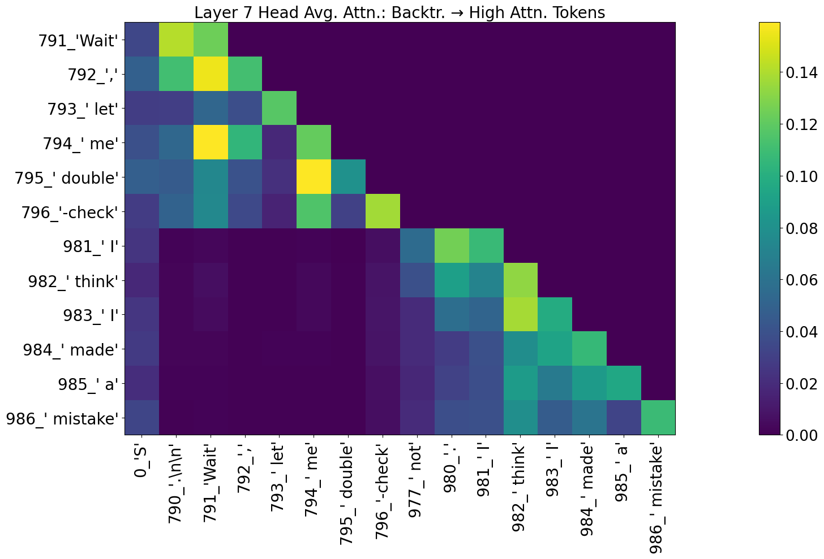
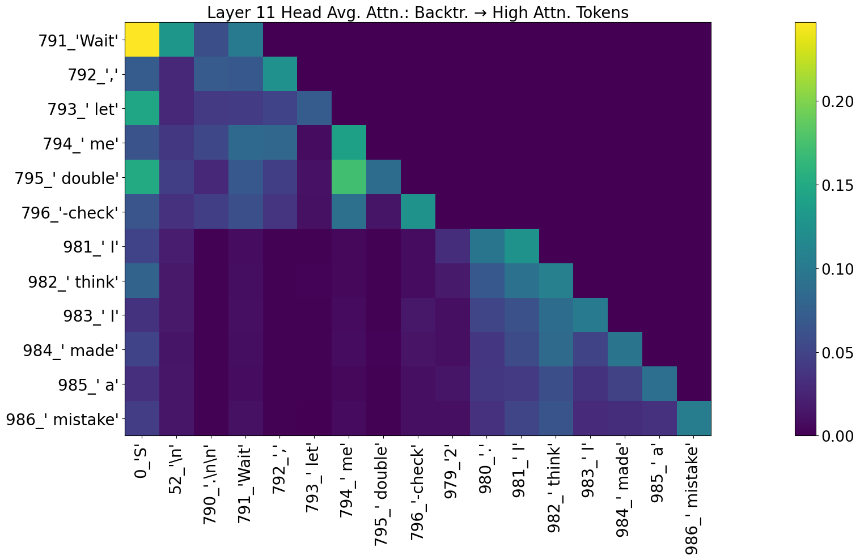
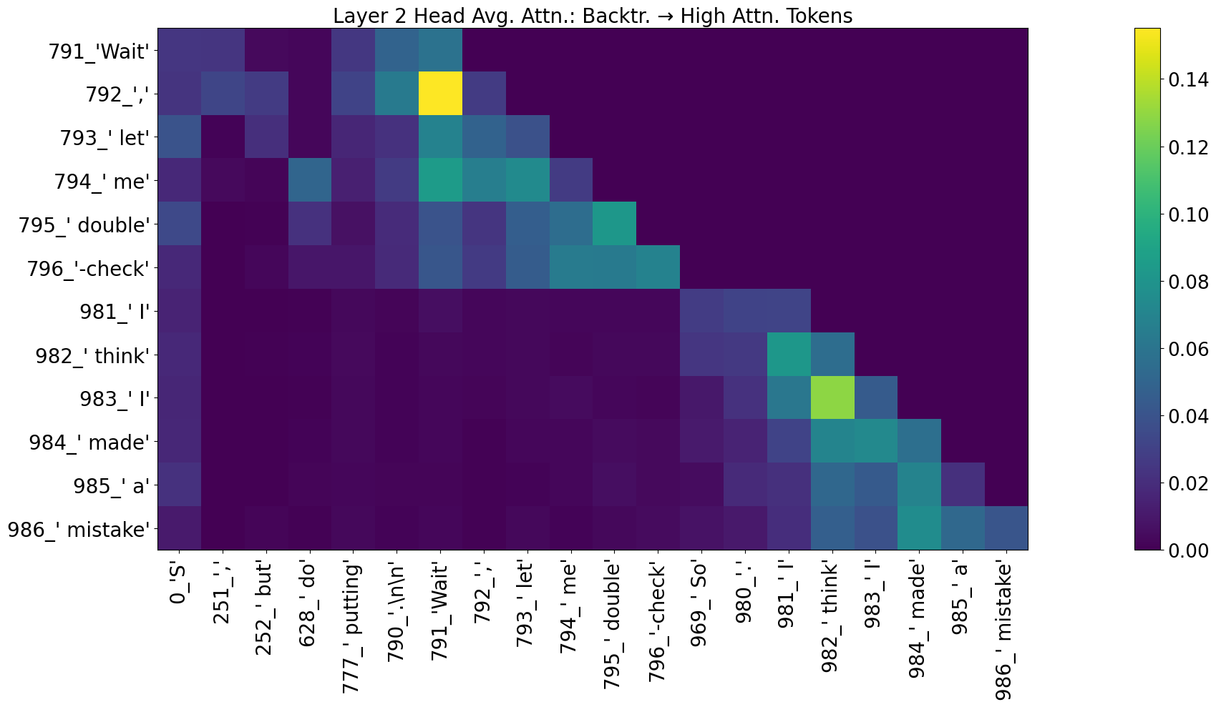
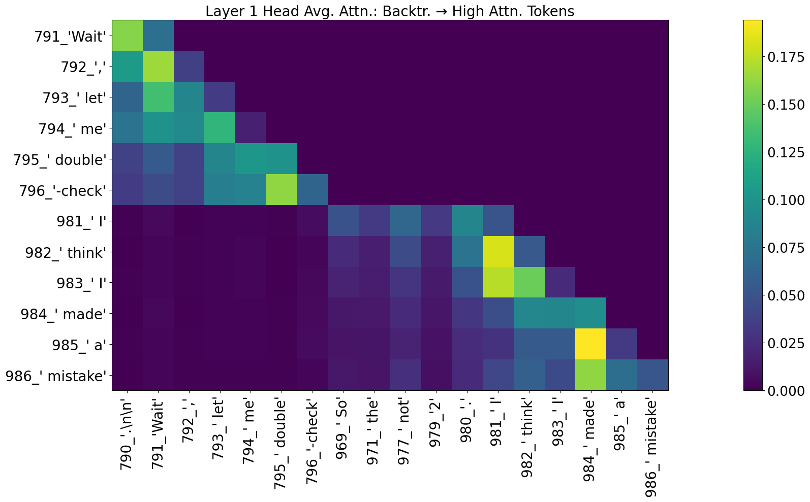

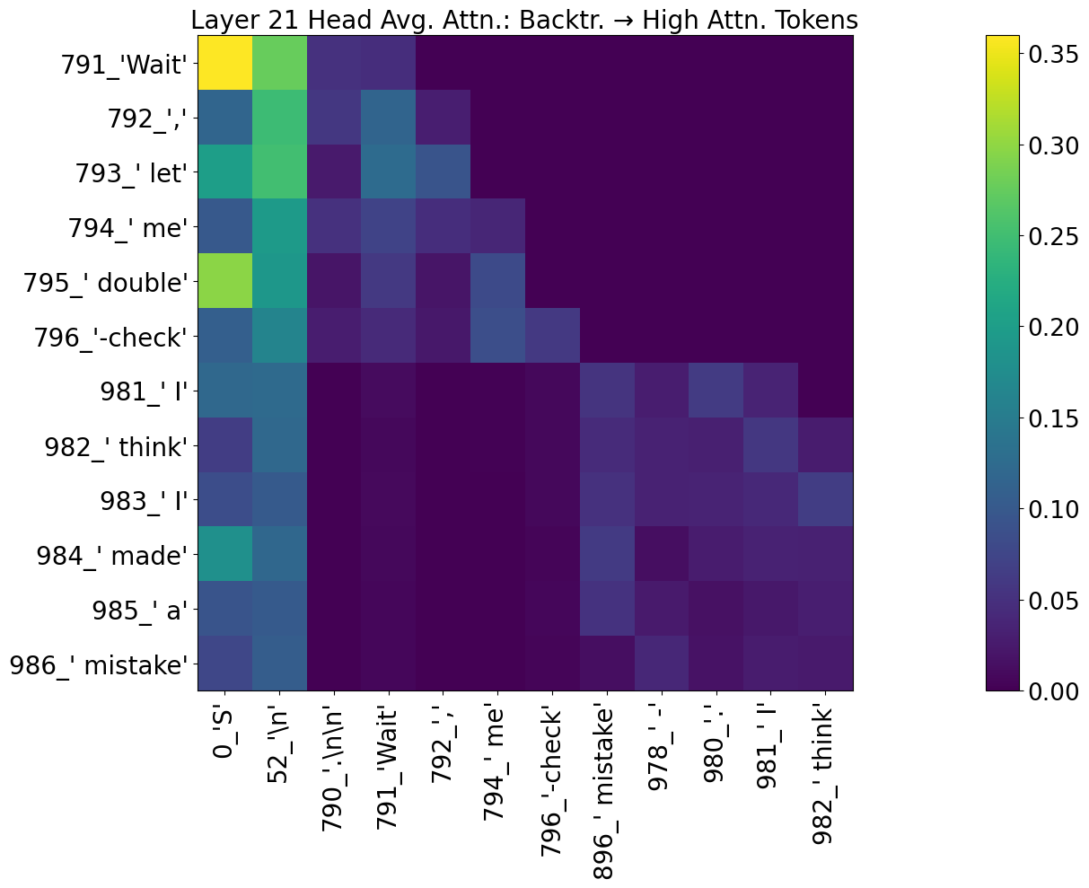
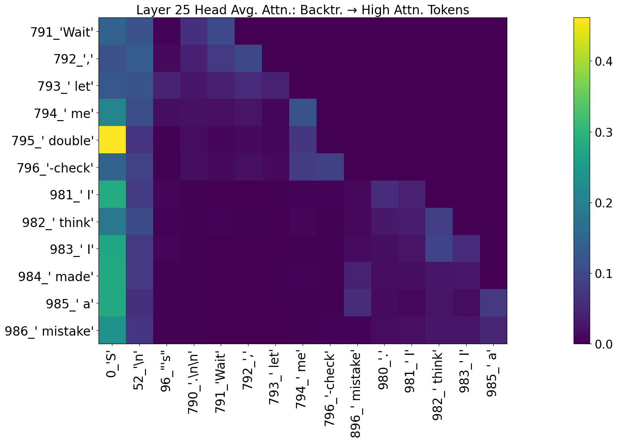

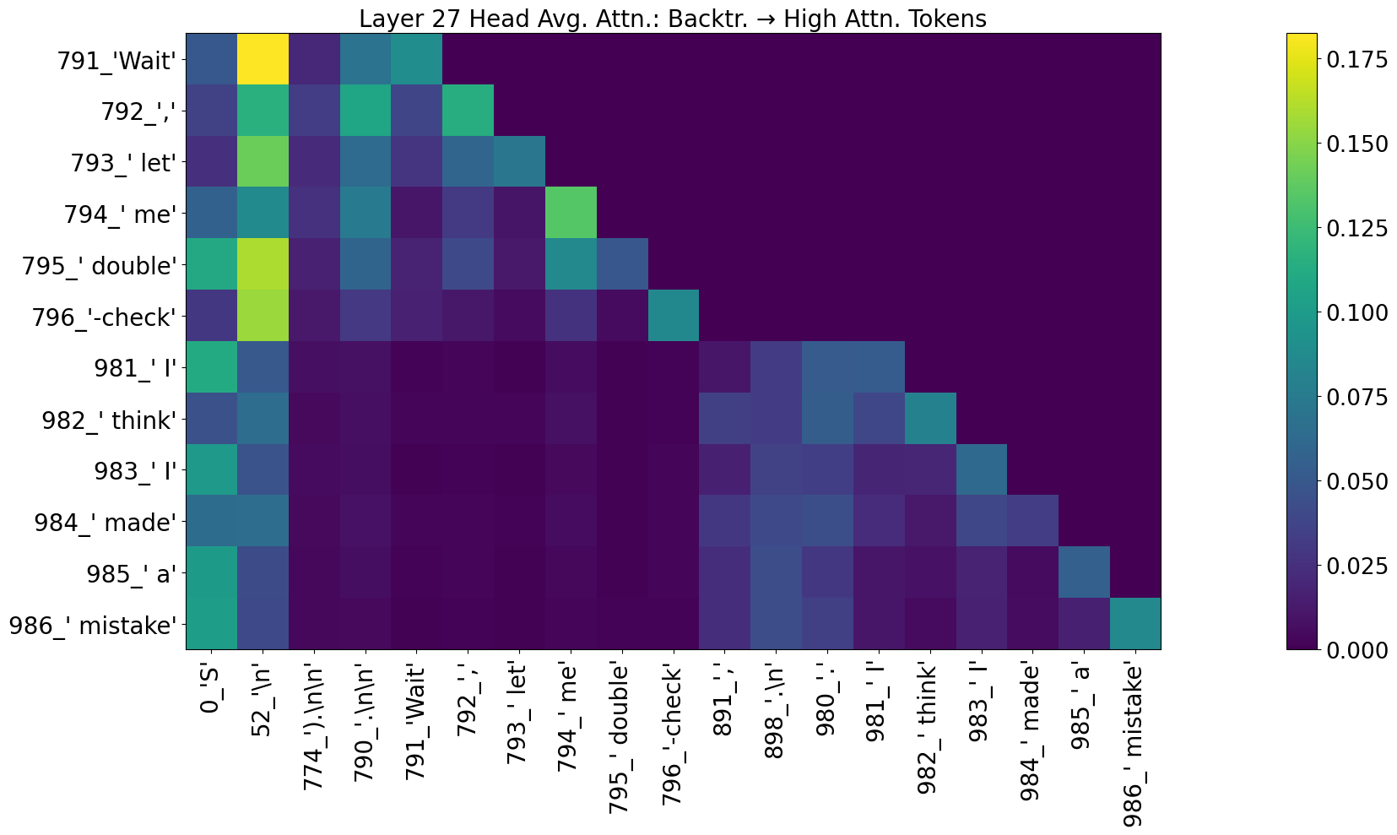
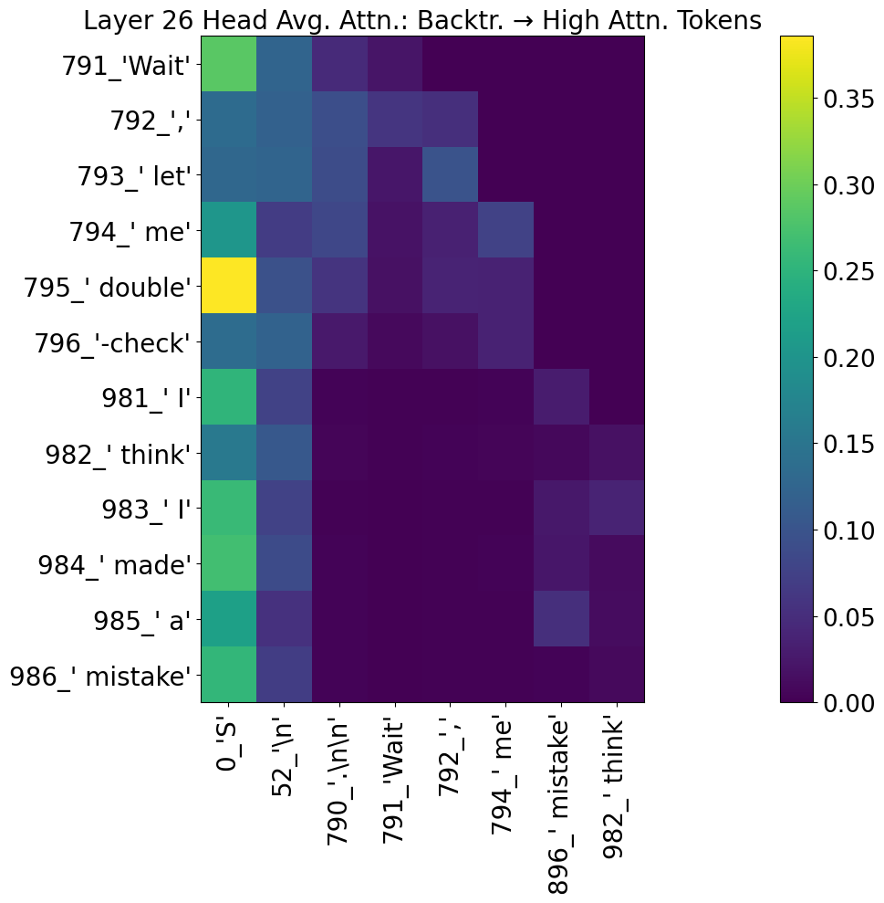

Figure 6: Attention maps at layers 1, 2, 7, 11, 21, 25, 26, 27 averaged across their respective 12 heads.

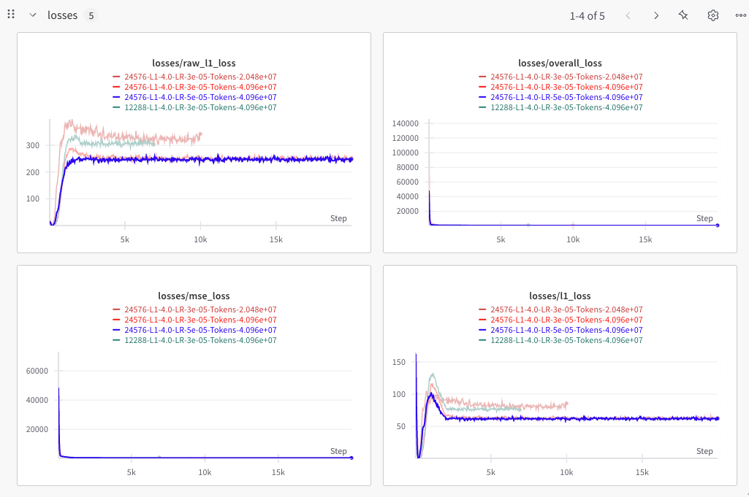
Figure 7: Training runs for the SAE. Different runs correspond to different hyperparameters including experimentation with learning rate, target layers (i.e. hook), and scheduler.
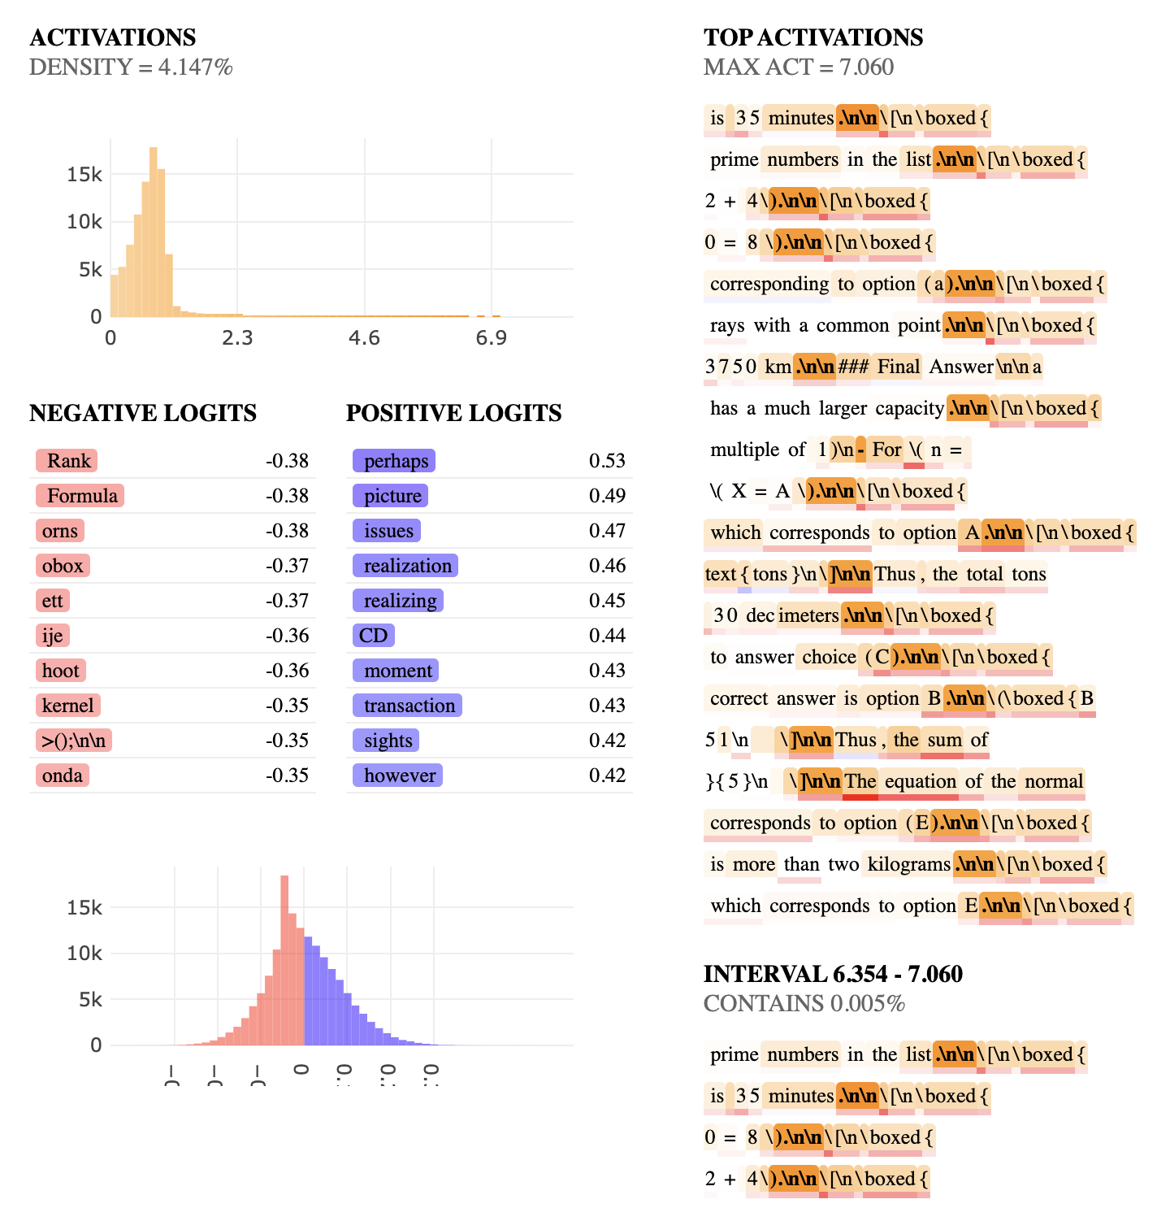
Figure 8: Feature 30 (activates for “\n\n” tokens for the final trained SAE on layer 21 alongside the previously mentioned Feature 19 (activates for “Wait” tokens). Feature 30 was found to be associated with feature 19 via prompt centric SAE visualizations.

Conclusion and Discussion
This project employed mechanistic interpretability to understand the emergent backtracking behaviors of reasoning models, specifically investigating the distilled model DeepSeek-R1-Distill-Qwen-1.5B.

Overall, our results can be summarized as follows:
R1: Consistently highlighted intentional and context-dependent backtracking processes
R2: Uncovered limitations regarding neuron interpretability
R3: Revealed surprising attention patterns related to special tokens
R4: Demonstrated feasibility of SAEs to isolate and interpret meaningful backtracking signals

Our findings suggest the model internally distinguishes correct from incorrect reasoning, initiating backtracking when necessary. Few limitations of my approach should be mentioned:

Model Scale: Results are from the smallest distilled DeepSeek variant, potentially differing from larger and more capable models where the exciting behavior is usually located.
SAE Feature Validation: Although promising, SAE-derived features still require robust validation. We have merely scratched the surface with the present research effort.
Dataset Diversity: Analyses relied exclusively on synthetic math CoTs, potential for bias.
Intervention Fidelity: My intervention setup (context length, re-generation) was constrained by computational resources. Different context lengths can yield different results.

Future work will focus on rigorously validating SAE features via linear probing and feature ablation, extending analyses to larger and more diverse models, developing steering vectors to actively guide models towards self-correction, and to ultimately find internal safeguards or mechanisms to guide models towards safer and more transparent reasoning trajectories.

Another tangent idea is to formally verify the hypothesis that the model’s internal state contains a notion of correct versus incorrect. A cool idea to test this hypothesis is to finetune the model to predict correct or incorrect based on a given CoT and see how well it generalizes to this idea.

Appendix
- For the notebooks to work with TransformerLens, you will need to add the string deepseek/DeepSeek-R1-Distill-Qwen-1.5B to the OFFICIAL_MODEL_NAMES array in loading_pretrained_from.py.

